**DAILY ONLINE ACTIVITIES SUMMARY**

|  |  |  |  |  |  |  |  |  |
| --- | --- | --- | --- | --- | --- | --- | --- | --- |
| **Date:** | **28-07-2020** | | | | | **Name:** | **Kanaka BS** | |
| **Sem & Sec** | **6th & A** | | | | | **USN:** | **4al17cs039** | |
| **Online Test Summary** | | | | | | | | |
| **Subject** | | **OR IA Module 2** | | | | | | |
| **Max. Marks** | | **30** | | **Score** | | | **-** | |
| **Certification Course Summary** | | | | | | | | |
| **Course** | **HTML CSS and JavaScript for Web developers** | | | | | | | |
| **Certificate Provider** | | | **Coursera** | | **Duration** | | | **5 Weeks** |
| **Coding Challenges** | | | | | | | | |
| **Problem Statement: Python Program for Print Number series without using any loop** | | | | | | | | |
| **Status: Solved** | | | | | | | | |
| **Uploaded the report in Github** | | | | | **yes** | | | |
| **If yes Repository name** | | | | | <https://github.com/kanakabs/Daily-Status> | | | |
| **Uploaded the report in slack** | | | | | **yes** | | | |

**ONLINE COURSE**

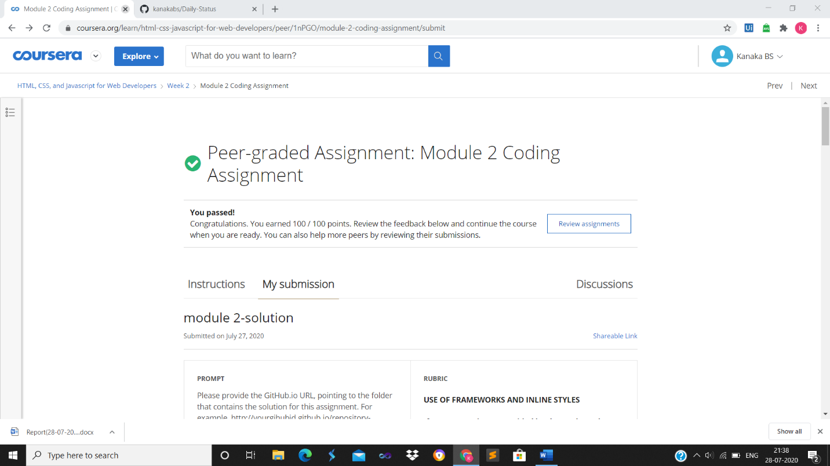

**ONLINE** **CODING**

**Python Program for Print Number series without using any loop**

def PrintNumber(N, Original, K, flag):

print(N, end = " ")

if (N <= 0):

if(flag==0):

flag = 1

else:

flag = 0

if (N == Original and (not(flag))):

return

if (flag == True):

PrintNumber(N - K, Original, K, flag)

return

if (not(flag)):

PrintNumber(N + K, Original, K, flag);

return

N = 10

K = 4

PrintNumber(N, N, K, True)

